The design in Pharma City (where has Unica Delica and Deli Pharma)

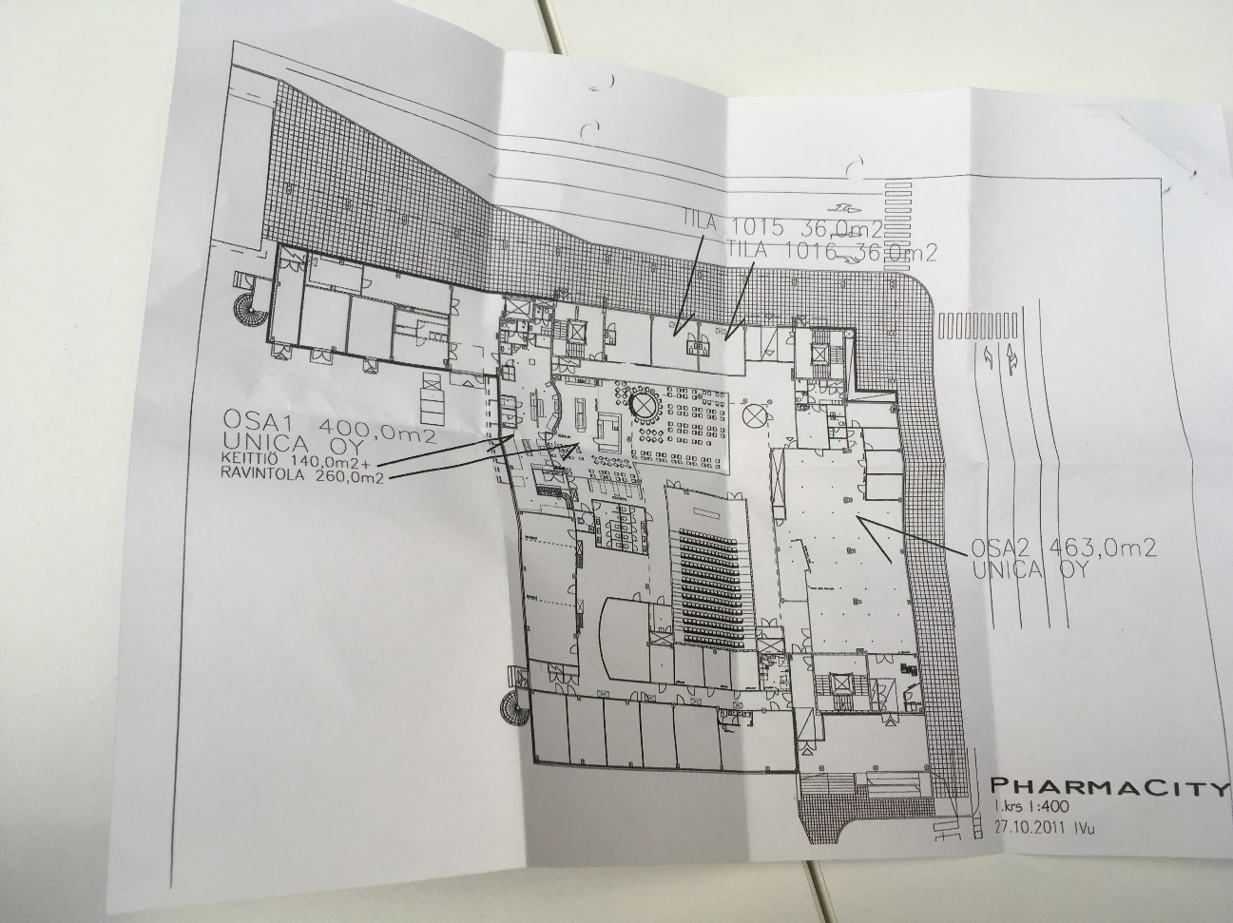

Survey result

<https://forms.office.com/Pages/AnalysisPage.aspx?AnalyzerToken=AO4sZ8tPPNCEym6dKIuPr5lCplKyk53y&id=hrwyq_ISOEuyYsV3WYLiQe9EjO8gTvdJlqOU_fja3TdUMTZBWVdPR0paNEZZSzM0WUg5U05WV1pTVS4u>

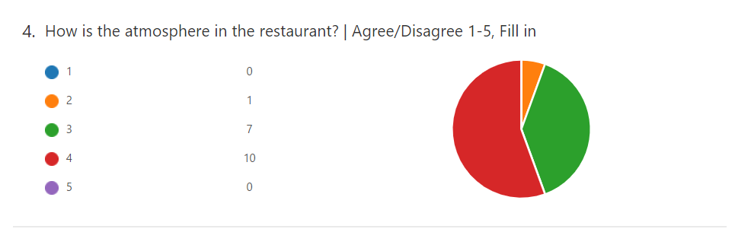

People who answer 1 (very good): 0

People who answer 2 (good): 1

People who answer 3 (acceptable): 7

People who answer 4 (poor): 10

People who answer 5 (very poor): 0

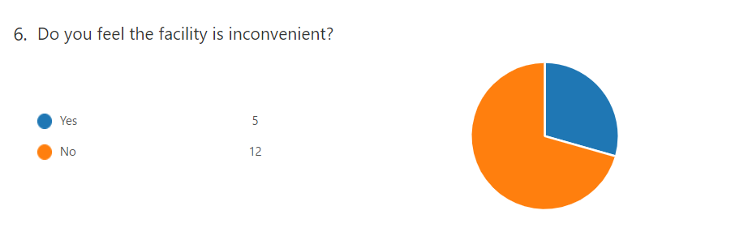

People who answer "Yes, it's inconvenient": 5

People who answer "No, I don't feel it's inconvenient": 12

***What I come up in my mind***

* **Customer feel the atmosphere in Unica Delica is not good for lunch**

the factor can influence the atmosphere:

-->the distance to the next person

-->the color of the facilities (e.g. wall, table etc)

Maybe the atmosphere between in Unica Delica and in Deli Pharma is very differenced

in Unica Delica: wall color is white and the distance to the next person is closer than in Deli Pharma

in Deli Pharma: wall color is natural and the distance to the next person is more far than in Unica Delica and there are more separated seats in Deli Pharma. The distance to the ceiling is more than the one of Unica Delica which can give some open impressions to the space.

* **Customer feel the facility is not so inconvenient**

the facility or the system to take lunch is almost same on every student restaurant. I think therefore people feels the facility is not inconvenient.

The color influence people's attitude

the color influence how people look the food.

For example, if the wall or facility color is a warm color like red or orange, people feel the food looks more delicious and people tend to feel time passes faster than other colors. On the other hand, if the wall or facility color is a cool color like blue or green, people feel the food looks not delicious. But people can concentrate more than other warm colors.

So, I think changing the color of the wall or the table has some possibilities to improve the atmosphere in Unica Delica.

