Project reflections

Table of Contents

1 Analysis of work efforts and problems 1

1.1 What happened during the different Phases? 1

1.2 Collaboration with the client 2

1.3 Technical problems/success 2

2 Fulfillment of the goal 2

2.1 Summary of achievements 2

2.1.1 Competitor mapping & analysis 2

2.1.2 Surveys (online & face-to-face), result analysis and proposed actions 3

2.1.3 Advertising, visibility and brand image 3

2.2 How the project will continue 4

3 Appendix page 5

3.1 Stakeholder Map 5

3.2 Competitor Analysis 6

3.3 Signage 7

PROJECT IDENTITY

2020 / Spring, Business Development - Unica

Participants of the group

|  |  |  |
| --- | --- | --- |
| Name | Phone | E-mail |
| Mikko Heinonen |  | mikko.heinonen@edu.turkuamk.fi |
| Michelon Justine |  | justine.michelon@edu.turkuamk.fi |
| Jannet Mathilde |  | mathilde.jannet@edu.turkuamk.fi |
| Satsuki Okada |  | satsuki.okada@edu.turkuamk.fi |
| Lauri Nieminen |  | lauri.nieminen1@edu.turkuamk.fi |
| Camille Duparc |  | duparc_camille@orange.fr |
| Joonas Raittila |  | Joonas.raittila@edu.turkuamk.fi |

**Web site:** <https://businessdevelopmentunicadelicapharma.blogspot.com/>

# Analysis of work efforts and problems

## What happened during the different Phases?

We all agreed to try and divide the workload evenly among all group members. Naturally some people worked more on some tasks due to prior knowledge on the subject matter or because of other restrictions such as work schedules or other courses and classes.

Planning (Winter 2019)

This project started off with minimal issues. We had weekly meetings and discussed about the viewpoints of the customer and Unica and tried to find similarities. We quickly came up with the idea for surveys and questionnaires and begun to work on those, and also worked on the ongoing tasks at the time, such as stakeholder mapping and blog writing.

The elevator speech included presentation of the team and the idea of our project we explained the problems with the Deli pharma and how we should fix them we also told what we had done and what we were going to do.

Execution (Winter 2020)

We were disappointed in the number of results from the online survey, as we thought it would be more popular. However, this gave us some new ideas for the face-to-face surveys and we further improved the questions and begun to interview people in different restaurants in the Kupittaa area. The stakeholder map was completed along with the competitor analysis to add more value to the survey results in an effort to find correlation between the differences of the restaurants and people’s opinion on them. We continued with our weekly meetings to keep everyone on track and to review our progress.

Results & analysis (Spring 2020)

With the data from both of the surveys and the competitor analysis, we scheduled a meeting with the product owner to discuss about the results and further actions. The product owner was pleased to find out about the depth of our competitor analysis and found the survey data to be interesting. We also pointed out some possible improvements to Unica’s visibility and social media presence booked a meeting to discuss with Unica’s social media manager. After the meeting we shifted our focus to work on the final report and the final tasks revolved around increasing the visibility.

## Collaboration with the client

We presented our survey analysis and methods to the client and discussed about the results and possible future actions.

We also gave some ideas on social media presence and scheduled a meeting with Unica’s social media responsible. Our ideas to develop Unica’s social media channels were to make them more solid and to focus and create some colour world that would based to Unica’s logos colours and some other colours that somehow describes Unica. We also talked that every published photo and message should have some meaning and we also mentioned about things that currently are good in Unica’s social media channels. In latest meeting with Jenna Särkkä we discussed much about things and changes that are Unica us going to do.

Social media meeting with Unica was 25th of march and we discussed by Microsoft teams about social media channels of Unica and also changes and things that are going on in the company.

## Technical problems/success

We experienced some minor issues in the beginning regarding usability and access to certain services (Trello, Teams, blog). However, all of those issues were solved almost immediately, either by guidance or figuring out the solution ourselves.

# Fulfillment of the goal

## Summary of achievements

### Competitor mapping & analysis

We visited every lunch restaurant in Kupittaa area during winter 2019-2020 and collected information on them. Based on that data, we compiled the competitor analysis.

Most of lunch restaurants in Kupittaa are mainly catering for students (Assarin Ullakko, Dental, Delica, Linus, Sodexo). The analysis includes the following 11 restaurants: Assarin Ullakko, Mauno, Deli Pharma, Delica, Sodexo Lemminkäinen, Linus, Taito, Dental, Amistoteles, Pohjola Sairaala and Upseerikerho.

Statistics that we compared were the lunch price, opening hours, meal options/diversity, services and spaces. For students, the major differences between these restaurants is the student discount that all of them don’t provide (Mauno, Taito, Pohjola Sairaala and Upseerikerho).  
Deli Pharma prices are little bit higher than other places although there’s student discount. Deli Pharma’s strengths are also their large salad collection and longer open hours than Mauno, Taito, Amistoteles, Pohjola Sairaala or Upseerikerho.

Mauno and Deli Pharma are significant competitors to each other because of their near location, as their restaurants in Electro- and BioCity are opposite sides of street.

### Surveys (online & face-to-face), result analysis and proposed actions

In the beginning of the project we started to create face-to-face and online surveys, the questions were created together as a group in meetings. We didn’t have any problems coming up with questions and views because everyone was actively taking part in the task.

The internet surveys did not go as planned because not so many people answered it, although it only took about 5 minutes or less to fill. We sent it to about 300 students and we only got around 20 answers. But we did get some pretty good feedback from it; People weren’t aware of the conference rooms in Delica and they also thought that atmosphere there was great.

In the face-to-face surveys we asked similar questions that we came up in our meetings, like in the online survey. The places where we surveyed people were Unica Linus, Unica Delica, Sodexo Lemminkäinen, Mauno, Deli Pharma and Assarin Ullakko. We surveyed people during lunch hours, and we got significantly more answers than in the online survey, mostly because people were very approachable and eager to give feedback. We also had more diversity in the answers because there were also workers eating there and not just students.

### Advertising, visibility and brand image

We found out that Unica Delica & Deli Pharma are relatively hard to find if you are not familiar with the Kupittaa area, as our exchange student members pointed out to us. We came up with the following solutions to increase visibility and direct more people to the restaurants.

1. Direction/easel sign boards near the entrance
2. Stickers with the Unica logo on the side of the street and on the windows
3. Stickers/footprints on the floor as route markers

This new signage will help new customers to recognize the restaurant and help to bring in new customers. There is already a lot of competition in the Kupittaa area, so the restaurant needs to make a itself more visible.  
This is important because in relation with traffic and communication issues they also need to guide and inform the customer, as they need to find what they are searching.  
The signage is part of the approach to satisfy the customers helped them to reach their needs, in this case to reach it to the restaurant. This is quality management based on service.

The main points on improving signage:

1) Try to create persuasive signage in addition to the informative signage

We will try to appeal the consumers with some attractive sentence and attractive image or promotion.

2) Communicate in English and in Finnish

Lots of consumer are foreign people and it’s very important to integrate all the targets and to not put people aside.

3) Used interior and exterior signage

We will try to develop exterior signage to increase the visibility of the company and interior signage to enable consumer to better orientate people on the space

Exterior signage will boast the dynamic sales.

4) Used color of unica in signpost: green and white

Very important to keep a coherence and a habits in the head of consumer. We have to establish a graphic chart and to respect it.

5) Rely on original signage tools and creative design

Create something original and design to attract the eyes of people in the street maybe they can be surprising, but we have to keep in mind that you should respect the universe and the color coherence of the brand.

## How the project will continue

Due to the COVID-19 lockdown, this project was put to a halt soon after the outbreak in Europe. As the lockdown is still in place and the project is ending, it will not continue. But, due to the positive relationship with the product owner, we’re sure that our work will be put into good use when it’s possible.

Creating a team with very different people (compared to each other) and making it work smoothly.

Surveys and analysis. This is probably more important to our exchange students, as they got to interview the “local people” and gain more insight into Turku and it’s people.

# Appendix page

## Stakeholder Map

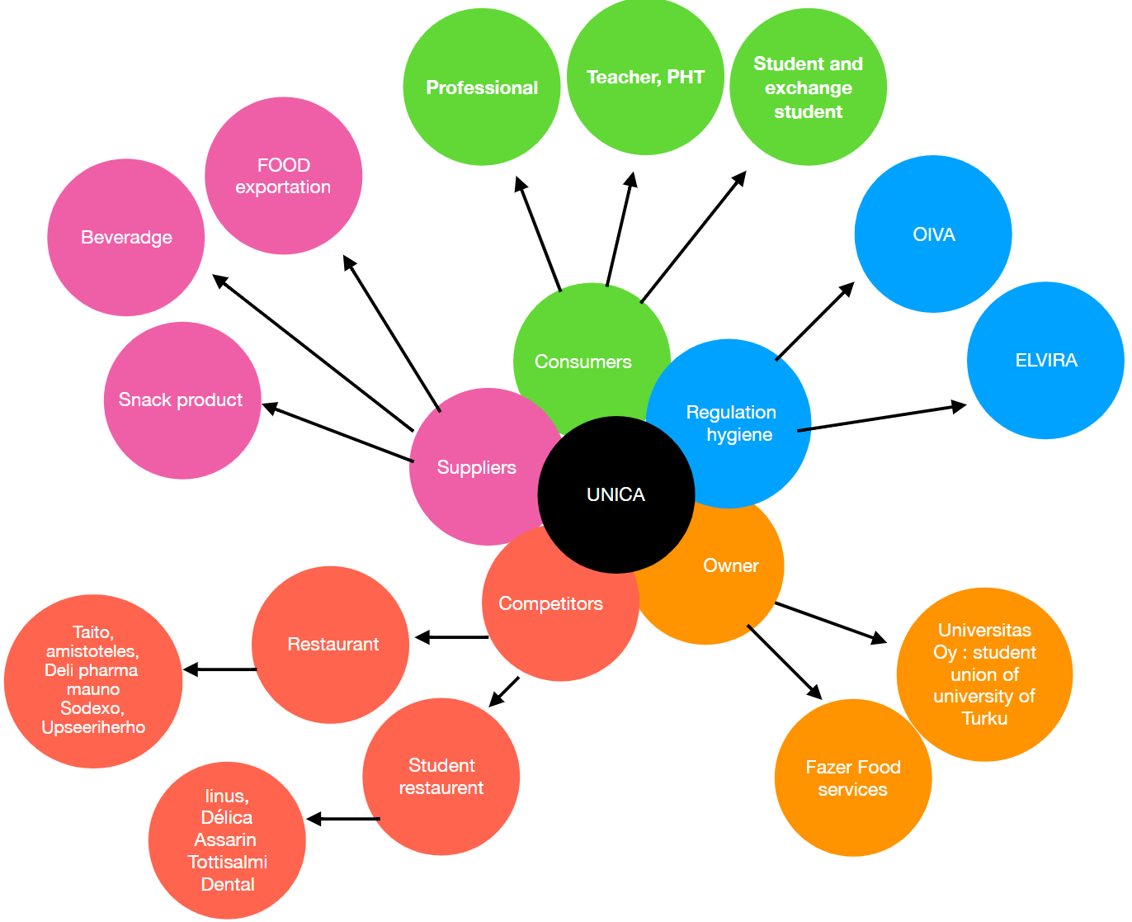

## Competitor Analysis

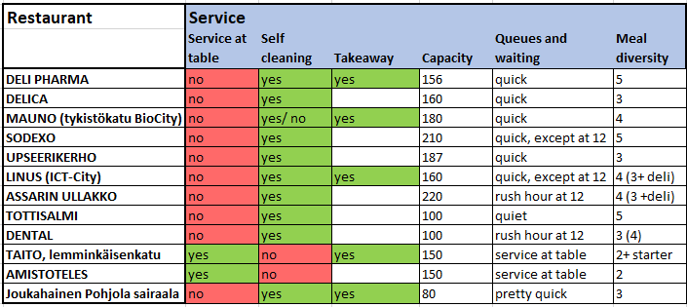

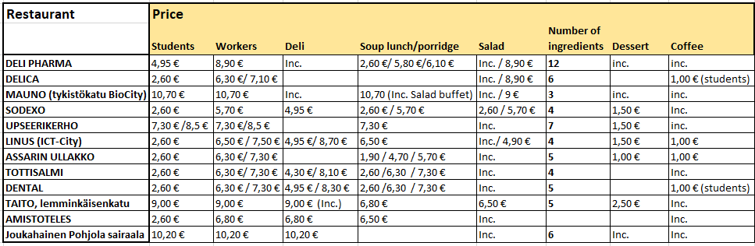

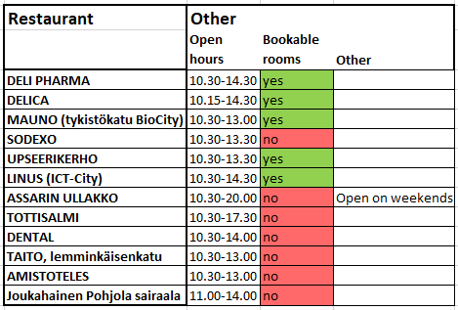

## Signage

